

**Physical Benefits**

Students build muscle strength while increasing flexibility. Young dancers develop a sense of balance and improve agility and coordination. Importantly, children also develop body awareness and learn correct posture. These benefits extend beyond a student's involvement with dance, helping youth involved in other disciplines, such as sports and martial arts. Studies have shown that physical activity helps children relieve stress and feel relaxed. It also is a great way to help your child develop a positive lifelong attitude about staying active and healthy.

**Developmental Benefits**

Dance classes are fun and a great way to meet new friends. Young dancers develop essential social skills through interaction with other students. Group choreography fosters teamwork, communication, trust and cooperation. Dance also has been proven to nurture important life skills, such as discipline and focus. Dancers naturally display confidence, self-esteem and poise. These skills are developed through participating in dance performances.

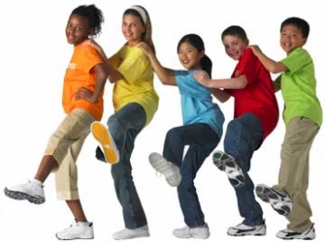

University Center for Performing Arts. (2011). *Dance provides youth with mind and body benefits.* Retrieved from http://www.universitycenterfortheperformingarts.com/about-ucpa/dance-provides-youth-with-mind-and-body-benefits.php

[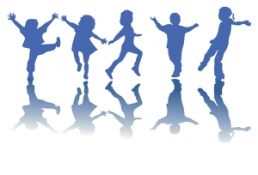](http://pureyoga.files.wordpress.com/2010/12/dancing-small22.jpg)

**Artistic Benefits**

One of the greatest benefits of dance is that it sparks a child's imagination and nurtures individual creativity in a unique way. Dance classes share the joy of physical self-expression in a supportive and structured setting. This can have a positive impact on children who have limited physical abilities, who act out or who have a difficult time sitting still. Involving children in dance also teaches the basic elements of creative movement, such as time, space, rhythm and design. While people may not be as familiar with modern dance as with ballet or jazz, modern dance in particular honors the creative spirit and celebrates the individual. Modern dance does not simply conform to conventional movements, shapes and patterns. Instead, it requires the young dancer to learn movement from the inside out, nurturing the body and focusing the mind. This form of dance especially is welcoming to children of all shapes, sizes and genders.

BENEFITS OF DANCE

**“you can dance anywhere, even if only in your heart.”**